**(I)Continue Statement**

#import <Foundation/Foundation.h>

int main ()

{

/* local variable definition */

int a = 10;

/* **do** loop execution */

**do**

{

**if**( a == 15)

{

/* skip the iteration */

a = a + 1;

**continue**;

}

NSLog(@**"value of a: %d\n"**, a);

a++;

}**while**( a < 20 );

return 0;

}

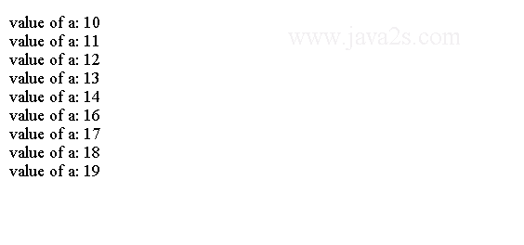

**(II) Skipping for**

#import <Foundation/Foundation.h>

int main ()

{

int i;

**for** (i = 0; i < 5; i++)

{

**if** ((i % 2) != 0)

{

**continue**;

}

NSLog (@**"The value of i = %i"**, i);

}

return 0;

}

The code above generates the following result.

